SCHOOL OF CIVIL & ENVIRONMENTAL ENGINEERING (SCEE)
Annex-A

NATIONAL UNIVERSITY OF SCIENCE & TECHNOLOGY (NUST)
H-12 SECTOR, ISLAMABAD

ORIENTATION PROGRAM OF SCEE – 2026

Day-1 (Wednesday 2nd Sep 2026)
Time (Hours) | Events | Venue
0900 | Reception and Welcome at SCEE | SCEE Building
0900-1100 | Registration / Documents Collection | NICE- Room 025, 026 & 027  IESE- Room 121 & 122  IGIS - Room 123
0945-1130 | Briefing and QA Sessions with Parents Only | Jinnah Auditorium/NBS Hall (broadcast)
1100-1130 | Alumni Talks | SCEE Seminar Hall
1130-1200 | Tea Break | Main Lobby SCEE
1145- 1200 | Parents are requested to return to SCEE Seminar Hall for SCEE Brief/ Principal & Dean SCEE Address | SCEE Seminar Hall
1200-1210 | SCEE Brief | SCEE Seminar Hall
1210-1240 | Alumni Talks | SCEE Seminar Hall
1240-1300 | Principal & Dean SCEE Address | SCEE Seminar Hall
1300-1400 | Lunch/Prayer Break | Open
1400-1600 | Meet your OGs | NBS Ground
1600-1700 | Gathering Freshmen for Batch Photo | Convocation Ground
1700-2100 | Batch Photo, Societies March, Panaflex Reveal | Convocation Ground
Day-2 (Thursday 3rd Sep 2026)
Time (Hours) | Events | Venue
0900-1000 | Qalam and LMS Briefing | SCEE Seminar Hall
1000-1015 | SCEE Library Briefing | SCEE Seminar Hall
1015-1145 | SCEE Institute Visit | Respective Institute
1145-1300 | Ice Breaking Activities | Respective Institute
1300-1400 | Lunch/Prayer Break | Open
1400-1900 | OG Activities + Clubs/Societies Activities | NUST/NBS Ground
1800-2100 | Drama by NDC | Jinnah Auditorium
Day-3 (Wednesday 4thSep 2026)
Time (Hours) | Events | Venue
1000-1230 | Life at NUST (Registrar + FAO + Alumni) | Jinnah Auditorium + broadcast to NET Hall
1300-1400 | Lunch/Prayer Break | Open
1400-1600 | Closing Ceremony | Jinnah Auditorium
1600-1900 | Bazm Night/ Society Stall | Jinnah Auditorium

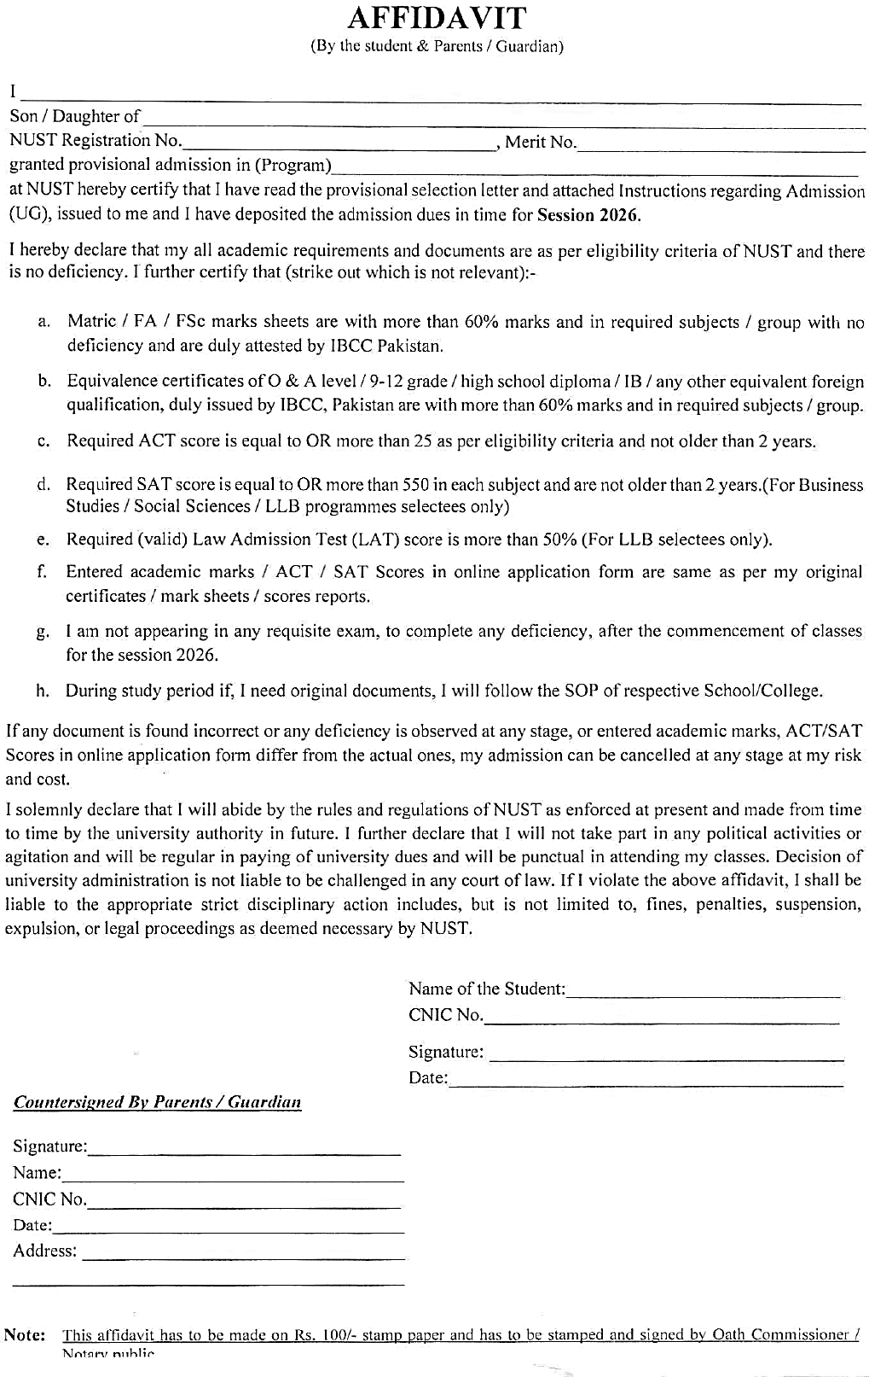
Annex-C

NATIONAL UNIVERSITY OF SCIENCES AND TECHNOLOGY (NUST)
Annex-D

SCHOOL OF CIVIL AND ENVIRONMENTAL ENGINEERING
NUST INSTITUTE OF CIVIL ENGINEERING (NICE)
SECTOR H-12, ISLAMABAD, PAKISTAN, LANDLINE: +92-51-90854526

PARTICULAR OF WARDS OF DEFENCE SERVICE PERSONALS

Name of Student:
Program:
Father’s / Mother’s Name:
(Who is serving or retired from Army/Navy/Air force)
Service No:
Rank:
Arm / Svc / Department:
Last Appointment Before Retiring:
Alive / Deceased:
Photocopies of discharge certificate / pension book in case of retired personnel’s may also be attached.

Signature of the Parent Signature of the student
Date: Date:

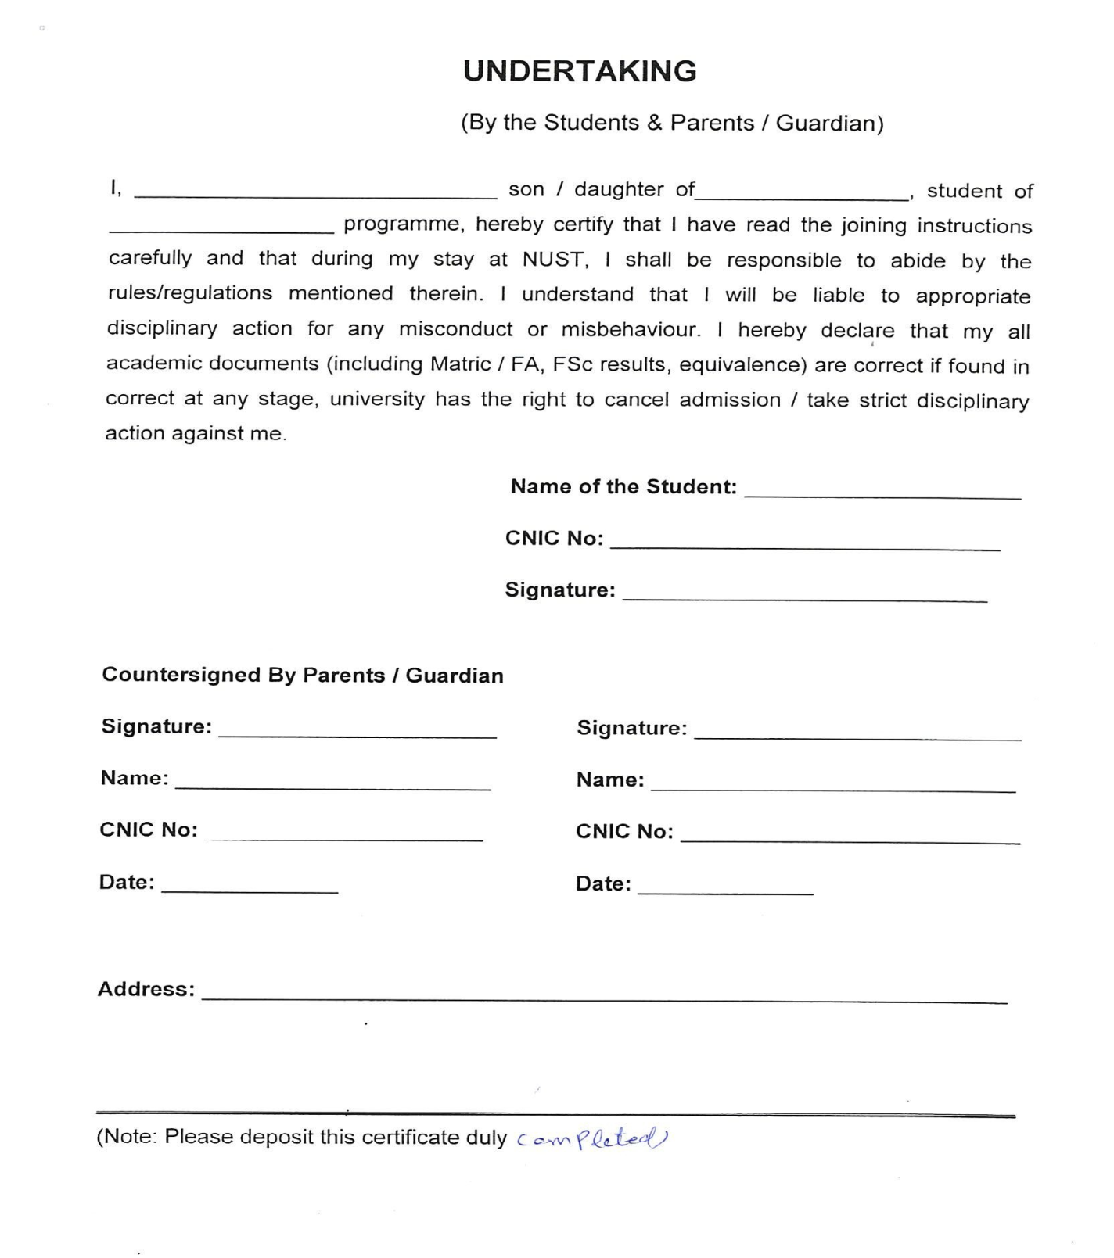
Annex-E

Medical Fitness Certificate
Annex-F

(Photograph)
Roll No/Registration No: -----------------------------------------------
Name: -----------------------------------------------
Father’s Name: -----------------------------------------------
Gender: -----------------------------------------------
Age: -----------------------------------------------
- Weight: ---------------- (kg) Height -------------------- (cm) BP ------------------------
- Lungs: ------------------------------------------------ Blood Gp. -------------------
- Heart: ------------------------------------------------------------
- Vision: Left Eye ------------- Right Eye ---------- Details of Glasses (if worn): ---------------
- Hearing: ---------------------------------------------------------
- Any Impediment in Speech: ----------------------------------------------------------------------------
- Any Disability: ----------------------------------------------------------------------------------------------
- Any Neurological / Psychiatric disease, (if yes, please give details). ------------------------
- Suffering from Hepatitis B / Hepatitis C / HIV (AIDS) --------------------------------------------
- Any significant Disease Diagnosed in the past: ---------------------------------------------------
- Vaccinated (Yes/No/Partially). -------------------------------------------------------------------------
- Taking any medicine on regular basis (if yes, please give details). --------------------------
- Allergies if any: --------------------------------------------------------------------------------------------
- Any Communicable / Contagious Disease: --------------------------------------------------------
- Mark of Identification: --------------------------------------
I certify that I have examined Mr / Ms ----------------------------------------------------------------Son / Daughter of ------------------------------------------------------ who is an applicant for admission to Undergraduate/ Postgraduate Program at NUST and could not notice that he / she has any physical or mental disease and is FIT for undertaking studies.
Signature of Doctor with legible seal | Signature of Candidate (In presence of Doctor)
PM & DC No: | Signature of Candidate (In presence of Doctor)
Dated: | Dated:
Note for Candidate: Please present your medical fitness certificate at the concerned NUST College/School at the time of joining.

MEDICAL STANDARDS FOR ADMISSION
Study at NUST demands good physique and stamina. An applicant must have sound health so as to bear the strain of the course.
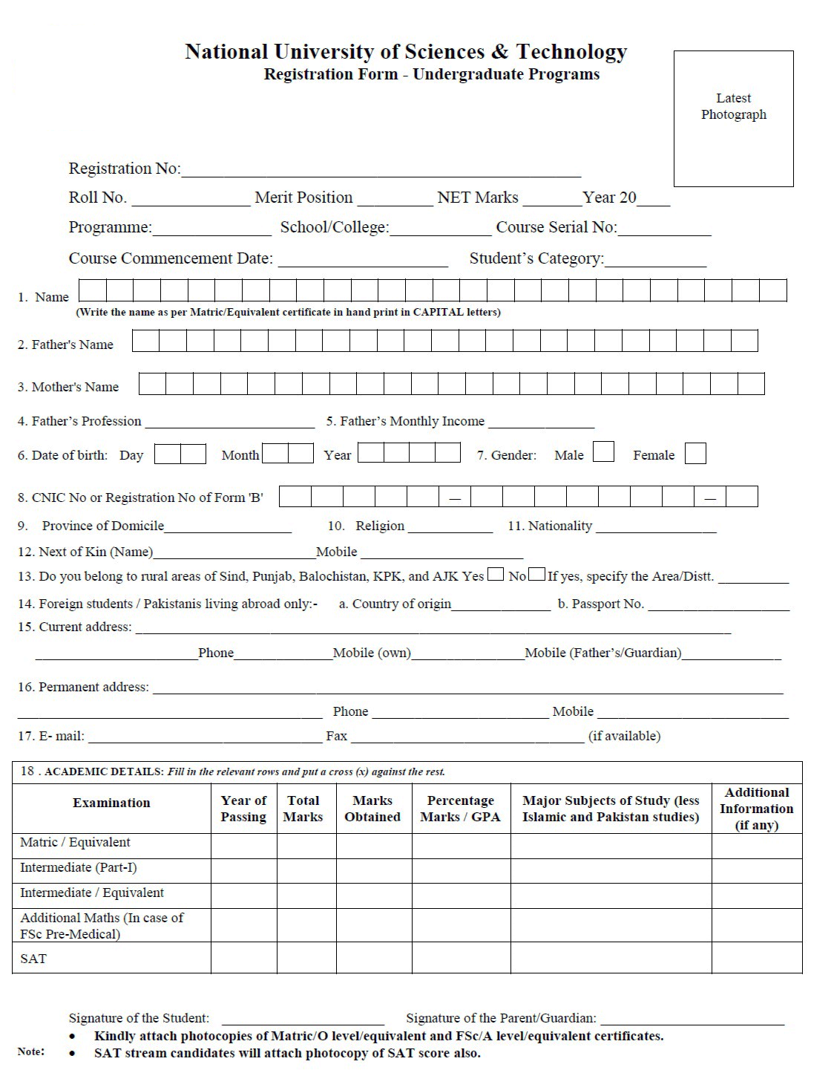
Annex-G

Annex-H

NATIONAL UNIVERSITY OF SCIENCES AND TECHNOLOGY (NUST)
SCHOOL OF CIVIL AND ENVIRONMENTAL ENGINEERING
NUST INSTITUTE OF CIVIL ENGINEERING (NICE)
SECTOR H-12, ISLAMABAD, PAKISTAN, LANDLINE: +92-51-90854526

UNDERTAKING

1. I, _________________________ S/O/D/O______________________________
do hereby solemnly affirm that if I fail to deposit my original documents (SSC/HSSC/O/A Levels) before 30th October 2026, I will not be allowed to sit in 1st Semester examination, and my registration will be cancelled.

2. I have entered correct marks of SSC/HSSC or O&A level equivalence in my online application form for NUST admission and all my SSC/HSSC or O&A level equivalency documents are attested by Inter Boards Coordination Commission (IBCC). I also hereby affirm that if any discrepancy is found in my entered marks at a later stage, I will be withdrawn from the University irrespective of my merit and Semester.

Dated: _________ 2026 Name:
Address:

_______________________________________________________________
Father/guardian of ___________________________________________________________
do hereby endorse the above undertaking.
Dated:_________ 2026 Name:
Address:

Note:
This undertaking must be provided on a Hundred-Rupee Stamp paper duly attested / stamped by OATH COMMISSIONER.

NATIONAL UNIVERSITY OF SCIENCES AND TECHNOLOGY (NUST)
Annex-I

SCHOOL OF CIVIL AND ENVIRONMENTAL ENGINEERING
NUST INSTITUTE OF CIVIL ENGINEERING (NICE)
SECTOR H-12, ISLAMABAD, PAKISTAN, LANDLINE: +92-51-90854526

UNDERTAKING (By the Student)

I, _________________________S/O/D/O_________________________

Student of BE Civil Engineering programme, hereby certify that I have read the instructions carefully given in Student Handbook (UG) and that during my stay at NUST, I shall be responsible to abide by the rules/regulations mentioned therein. I understand that I will be liable to appropriate disciplinary action for any misconduct or misbehavior.

Name of Student | ________________ | Registration # | __________________
Contact No | ________________ | Email Id | __________________
CNIC No | ________________
Present Address | _____________________________________________  _____________________________________________
Signature’s Student _______________

