SCHOOL OF CIVIL & ENVIRONMENTAL ENGINEERING (SCEE)
NATIONAL UNIVERSITY OF SCIENCE & TECHNOLOGY (NUST)
H-12 SECTOR, ISLAMABAD

ORIENTATION PROGRAM OF SCEE – 2024

Day-1 (Monday 2nd Sep 2024) – For Parents
Time (Hours) | Events | Venue
1000-1130 | Briefing and QA Sessions with Parents Only* | Jinnah Auditorium
1130-1200 | Tea Break | Jinnah Auditorium
1200-1300 | Principal & Dean’s Session (SCEE Presentation + Alumni Talks) | SCEE Seminar Hall
Day-1 (Monday 2nd Sep 2024) – For Students
0900 | Reception and Welcome at SCEE (NICE)
0900-1100 | Registration / Documents Collection | NICE- Room 110, 113 & 115  IESE- Room 25  IGIS - Room 26
1030-1100 | Alumni Talks | SCEE Seminar Hall
1100-1130 | Tea Break | Main Lobby SCEE
1200-1300 | Principal & Dean’s Session (SCEE Presentation + Alumni Talks) | SCEE Seminar Hall
1300 | Batch Photo | SCEE Lawn
1300 | Lunch & Prayer Break | Open
1300 | Departure to Convocation Ground for OG Activities | Convocation Ground NUST
Day-2 (Tuesday 3rd Sep 2024)
Time (Hours) | Events | Venue
0900 | Reception at respective Institutes | Respective Institutes
0900-1230 | Ice Breaking Activities | Respective Institutes
1300 | Lunch & Prayer Break | Open
1400-1700 | Life at NUST | Jinnah Auditorium
1730-2130 | Sports Opening Ceremony & Exhibition Matches | NBS Sports Ground
Day-3 to Day 5 (Wednesday 4th Sep to Friday 6th Sep 2024)
Time (Hours) | Events | Venue
0900-1300 | Inter-School Visits

* All parents will be guided straight to Jinnah Auditorium for address at 0930 hours while all the students of SCEE (NICE, IESE and IGIS) will proceed to SCEE (NICE) for documentation/ registration
*Respective Institutes will establish their desks at Gate-01 and Gate-02
Annex-C

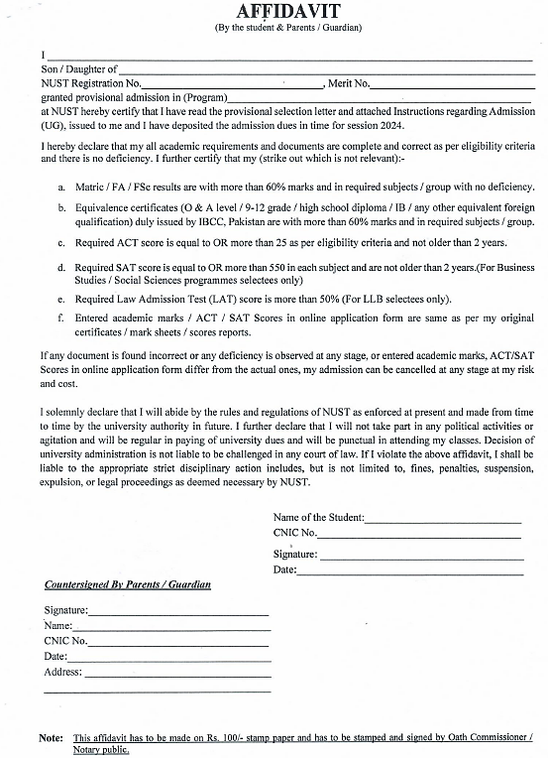

NATIONAL UNIVERSITY OF SCIENCES AND TECHNOLOGY (NUST)
Annex-D

SCHOOL OF CIVIL AND ENVIRONMENTAL ENGINEERING
NUST INSTITUTE OF CIVIL ENGINEERING (NICE)
SECTOR H-12, ISLAMABAD, PAKISTAN, LANDLINE: +92-51-90854501

PARTICULAR OF WARDS OF DEFENCE SERVICE PERSONALS

Name of Student:
Program:
Father’s / Mother’s Name:
(Who is serving or retired from Army/Navy/Air force)
Service No:
Rank:
Arm / Svc / Department:
Last Appointment Before Retiring:
Alive / Deceased:
Photocopies of discharge certificate / pension book in case of retired personnel’s may also be attached.

Signature of the Parent Signature of the student
Date: Date:

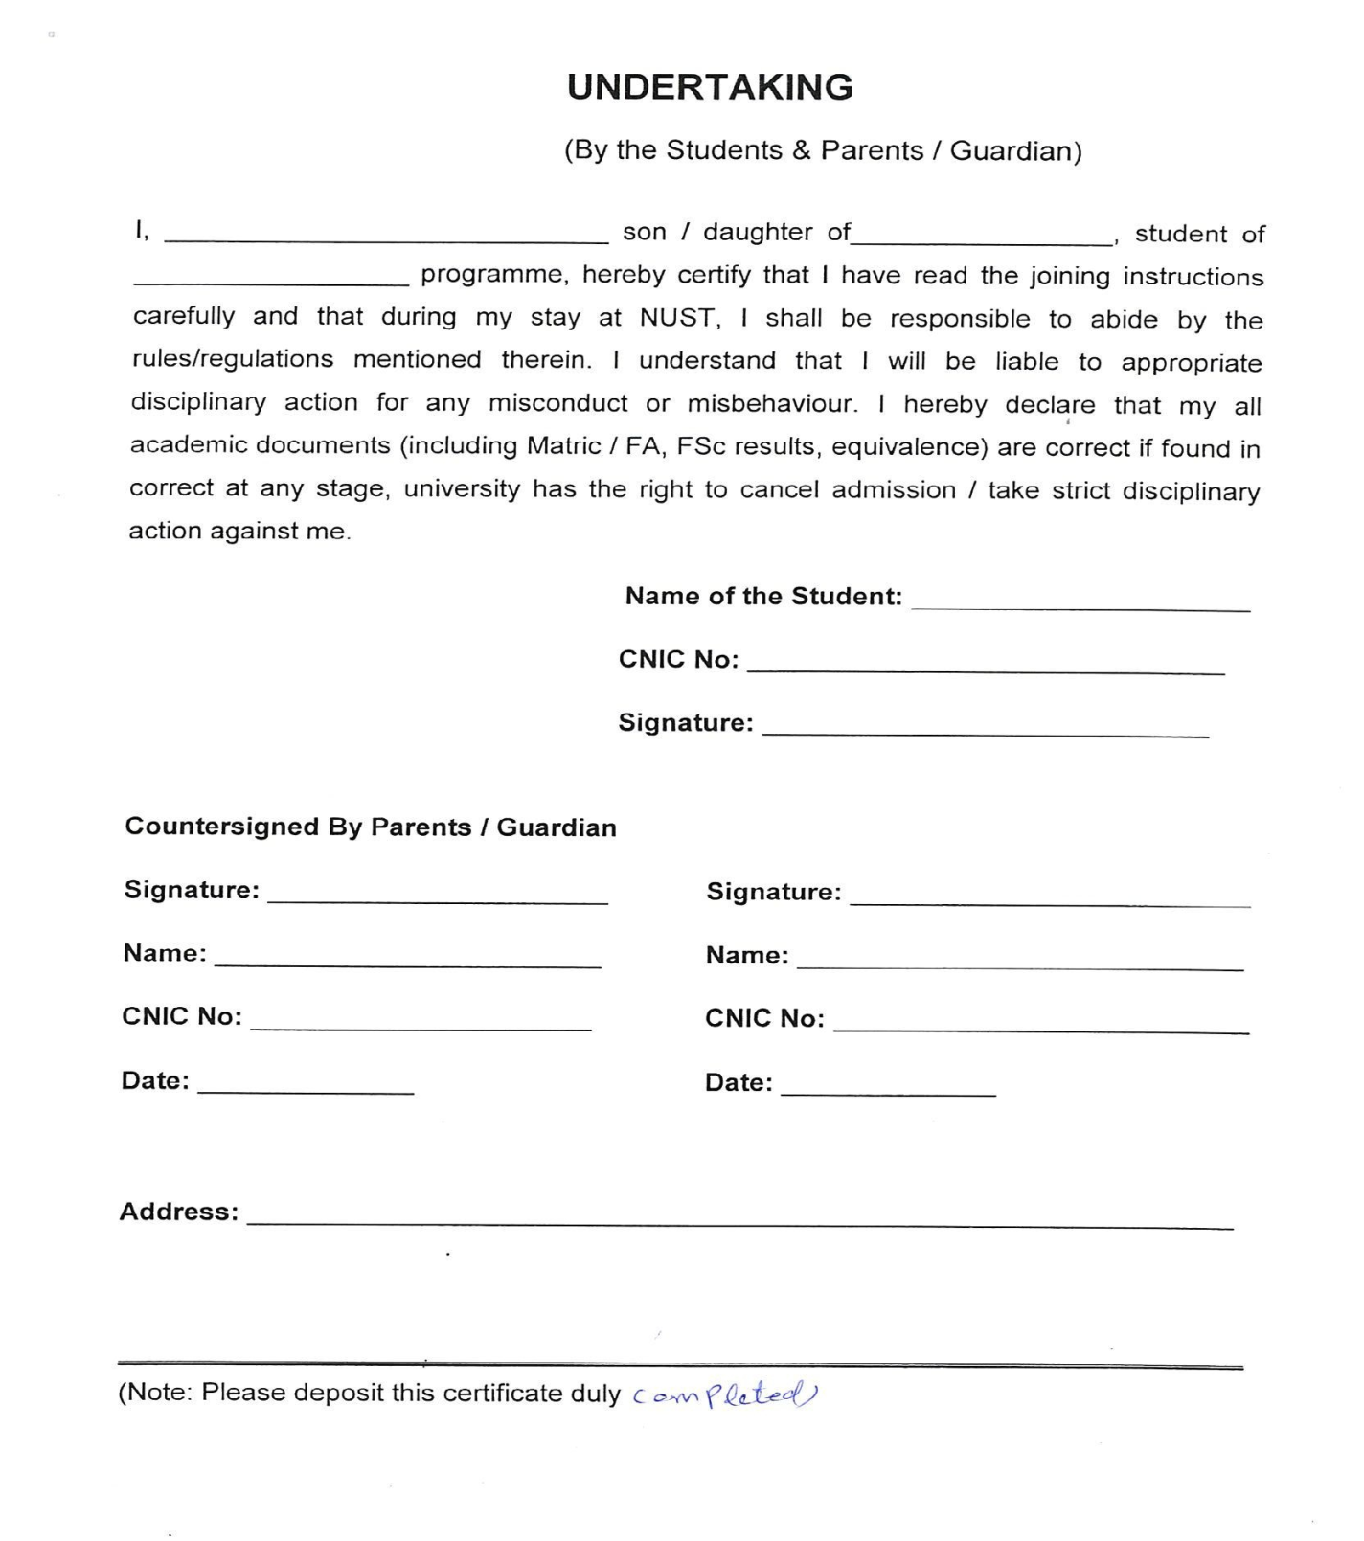
Annex-E

Medical Fitness Certificate
Annex-F

(Photograph)
Roll No/Registration No: -----------------------------------------------
Name: -----------------------------------------------
Father’s Name: -----------------------------------------------
Gender: -----------------------------------------------
Age: -----------------------------------------------
- Weight: ---------------------------------- (kg) Height -------------------- (cm) BP ------------------------
- Lungs: ------------------------------------------------------------ Blood Gp. --------------
- Heart: ------------------------------------------------------------
- Vision: Left Eye ----------------- Right Eye ---------------- Details of Glasses (if worn): ----------------
- Hearing: ---------------------------------------------------------
- Any Impediment in Speech: --------------------------------------------------------------------------------------
- Any Disability: --------------------------------------------------------------------------------------------------------
- Any Neurological / Psychiatric disease, (if yes, please give details). ------------------------------------
- Suffering from Hepatitis B / Hepatitis C / HIV (AIDS) -------------------------------------------------------
- Any significant Disease Diagnosed in the past: --------------------------------------------------------------
- Vaccinated (Yes/No/Partially). -----------------------------------------------------------------------------------
- Taking any medicine on regular basis (if yes, please give details). --------------------------------------
- Allergies if any: -------------------------------------------------------------------------------------------------------
- Any Communicable / Contagious Disease: -------------------------------------------------------------------
- Mark of Identification: --------------------------------------
I certify that I have examined Mr / Ms ----------------------------------------------------------------Son / Daughter of ------------------------------------------------------ who is an applicant for admission to Undergraduate/ Postgraduate Program at NUST and could not notice that he / she has any physical or mental disease and is FIT for undertaking studies.
Signature of Doctor with legible seal | Signature of Candidate (In presence of Doctor)
PM & DC No: | Signature of Candidate (In presence of Doctor)
Dated: | Dated:
Note for Candidate: Please present your medical fitness certificate at the concerned NUST College/School at the time of joining.
MEDICAL STANDARDS FOR ADMISSION
Study at NUST demands good physique and stamina. An applicant must have sound health so as to bear the strain of the course.
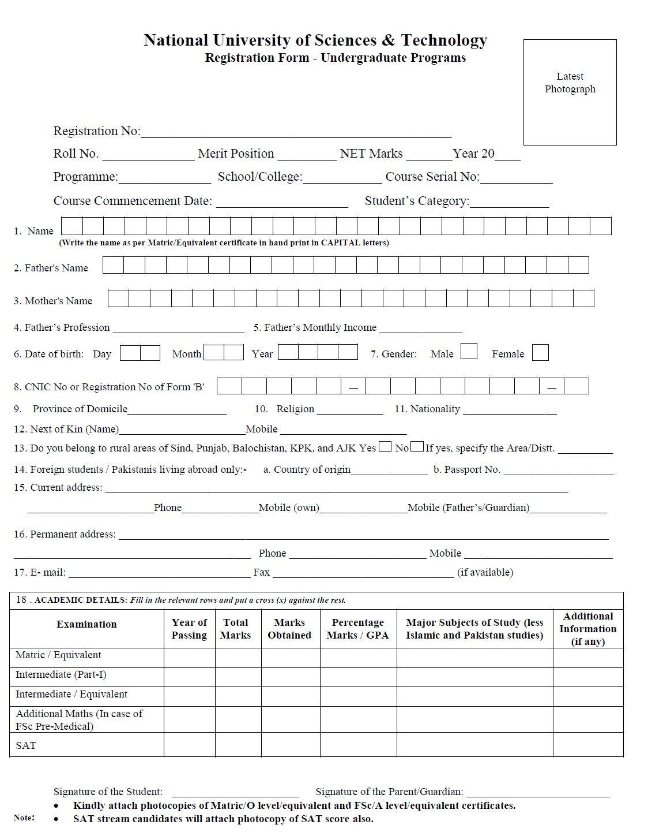
Annex-G

Annex-H

NATIONAL UNIVERSITY OF SCIENCES AND TECHNOLOGY (NUST)
SCHOOL OF CIVIL AND ENVIRONMENTAL ENGINEERING
NUST INSTITUTE OF CIVIL ENGINEERING (NICE)
SECTOR H-12, ISLAMABAD, PAKISTAN, LANDLINE: +92-51-90854501

UNDERTAKING

1. I, ____________________________ S/O/D/O_______________________________
do hereby solemnly affirm that if I fail to deposit my original documents (SSC/HSSC/O/A Levels) before 30th October 2024, I will not be allowed to sit in 1st Semester examination and my registration will be cancelled.

2. I have entered correct marks of SSC/HSSC or O&A level equivalence in my online application form for NUST admission and all my SSC/HSSC or O&A level equivalency documents are attested by Inter Boards Coordination Commission (IBCC). I also hereby affirm that if any discrepancy is found in my entered marks at a later stage, I will be withdrawn from the University irrespective of my merit and Semester.

Dated: _________ 2024 Name:
Address:

I,________________________________________________________________
Father/guardian of ___________________________________________________________
do hereby endorse the above undertaking.
Dated:_________ 2024 Name:
Address:

Note:
This undertaking must be provided on a Hundred Rupee Stamp paper duly attested / stamped by OATH COMMISSIONER.

