SCHOOL OF CIVIL & ENVIRONMENTAL ENGINEERING (SCEE)
Annex-A
NATIONAL UNIVERSITY OF SCIENCE & TECHNOLOGY (NUST)
H-12 SECTOR, ISLAMABAD

Orientation Program of SCEE - 2023

Date | Events | Time (Hours) | Venue
Monday  4th Sep 2023  Day-1 | Reception and Welcome at School | 0900 | NICE-SCEE
 | Registration /  Documents Collection | 0900-1100 | NICE- Room 110, 111, 112 & 113  IESE- Room 25  IGIS-Room 26
 | Briefing and QA Sessions with Parents Only* | 1000-1130 | Jinnah Auditorium
 | Alumni Talks | 1000-1100 | SCEE Seminar Hall
 | Tea Break | 1100-1130 | Main Lobby SCEE
 | Presentation-SCEE Brief | 1140-1200 | SCEE Seminar Hall
 | Address by Principal SCEE | 1200-1220 | SCEE Seminar Hall
 | Qalam Orientation | 1220-1240 | SCEE Seminar Hall
 | Lunch & Prayer Break | 1300 | Open
 | Departure to Convocation Ground for OG Activities | 1300 | Convocation Ground NUST
Tuesday  5th Sep 2023  Day-2 | Reception at respective Institutes | 0900 | Respective Institutes
 | Ice Breaking Activities | 0900-1230 | Respective Institutes
 | Lunch & Prayer Break | 1300 | Open
 | Life at NUST | 1400-1700 | Jinnah Auditorium
 | Sports Opening Ceremony & Exhibition Matches | 1730-2130 | NBS Sports Ground
Wednesday  6th Sep 2023  Day-3 | Inter-School Visits
Thursday
7th Sep 2023
Day-4
Friday
8th Sep 2023
Day-5
* All parents will be guided straight to Jinnah Auditorium for Address at 0930 Hours while all the students of SCEE (NICE, IESE and IGIS) will proceed to NICE-SCEE for documentation/registration
*Respective Institutes will establish their desks at Gate-01 and Gate-02
Annex-C

NUST INSTITUTE OF CIVIL ENGINEERING (NICE)
SCHOOL OF CIVIL & ENVIRONMENTAL ENGINEERING (SCEE)
NATIONAL UNIVERSITY OF SCIENCE & TECHNOLOGY (NUST)
H-12 SECTOR, ISLAMABAD

UNDERTAKING

I, ____________________________________ S/O/D/O_______________________________
do hereby solemnly affirm that I shall not indulge in any political or sectarian activity during the
course of my studies in BE (Civil Engineering) Session: 2023 - 2027 at NICE-SCEE, Islamabad

Dated: _________ 2023 Name:
Address:

I,_________________________________________________________________________
Father/guardian of ___________________________________________________________
do hereby endorse the above undertaking.
Dated:_________ 2023 Name:
Address:

Note:
This undertaking must be provided on a Hundred Rupee Stamp paper duly attested / stamped by OATH COMMISSIONER.

Annex-D

NUST INSTITUTE OF CIVIL ENGINEERING (NICE)
SCHOOL OF CIVIL & ENVIRONMENTAL ENGINEERING (SCEE)
NATIONAL UNIVERSITY OF SCIENCE & TECHNOLOGY (NUST)
H-12 SECTOR, ISLAMABAD

PARTICULAR OF WARDS OF DEFENCE SERVICE PERSONALS

Name of Student:
Program:
Father’s / Mother’s Name:
(Who is serving or retired from Army/Navy/Air force)
Service No:
Rank:
Arm / Svc / Department:
Last Appointment Before Retiring:
Alive / Deceased:
Photocopies of discharge certificate / pension book in case of retired personnel’s may also be attached.

Signature of the Parent Signature of the student
Date: Date:

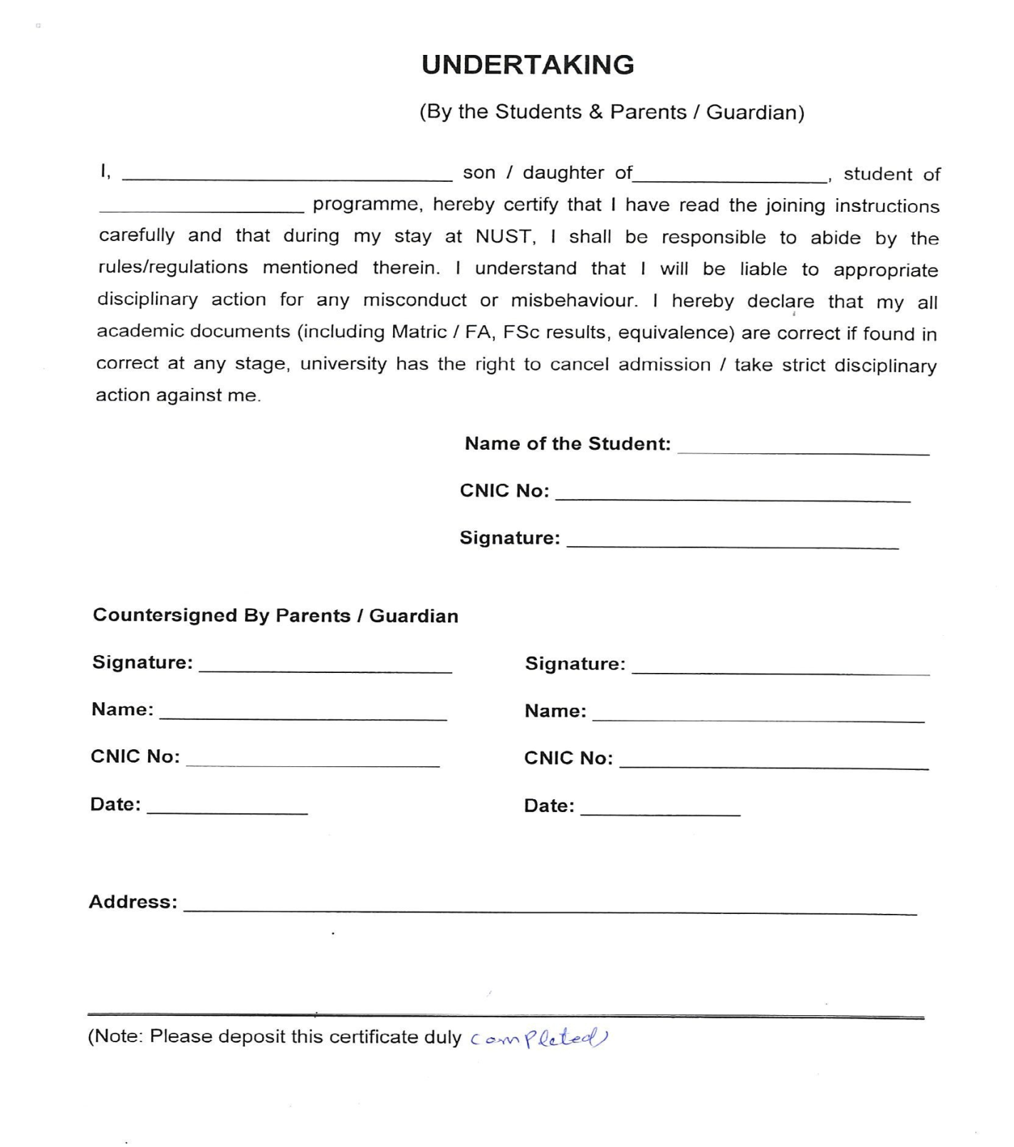
Annex-E

Medical Fitness Certificate
Annex-F

(Photograph)
Roll No/Registration No: -----------------------------------------------
Name: -----------------------------------------------
Father’s Name: -----------------------------------------------
Gender: -----------------------------------------------
Age: -----------------------------------------------
- Weight: ---------------------------------- (kg) Height -------------------- (cm) BP ------------------------
- Lungs: ------------------------------------------------------------ Blood Gp. --------------
- Heart: ------------------------------------------------------------
- Vision: Left Eye ----------------- Right Eye ---------------- Details of Glasses (if worn): ----------------
- Hearing: ---------------------------------------------------------
- Any Impediment in Speech: --------------------------------------------------------------------------------------
- Any Disability: --------------------------------------------------------------------------------------------------------
- Any Neurological / Psychiatric disease, (if yes, please give details). ------------------------------------
- Suffering from Hepatitis B / Hepatitis C / HIV (AIDS) -------------------------------------------------------
- Any significant Disease Diagnosed in the past: --------------------------------------------------------------
- Vaccinated (Yes/No/Partially). -----------------------------------------------------------------------------------
- Taking any medicine on regular basis (if yes, please give details). --------------------------------------
- Allergies if any: -------------------------------------------------------------------------------------------------------
- Any Communicable / Contagious Disease: -------------------------------------------------------------------
- Mark of Identification: --------------------------------------
I certify that I have examined Mr / Ms ----------------------------------------------------------------Son / Daughter of ------------------------------------------------------ who is an applicant for admission to Undergraduate/ Postgraduate Program at NUST and could not notice that he / she has any physical or mental disease and is FIT for undertaking studies.
Signature of Doctor with legible seal | Signature of Candidate (In presence of Doctor)
PM & DC No:
Dated: | Dated:
Note for Candidate: Please present your medical fitness certificate at the concerned NUST College/School at the time of joining.
MEDICAL STANDARDS FOR ADMISSION
Study at NUST demands good physique and stamina. An applicant must have sound health so as to bear the strain of the course.
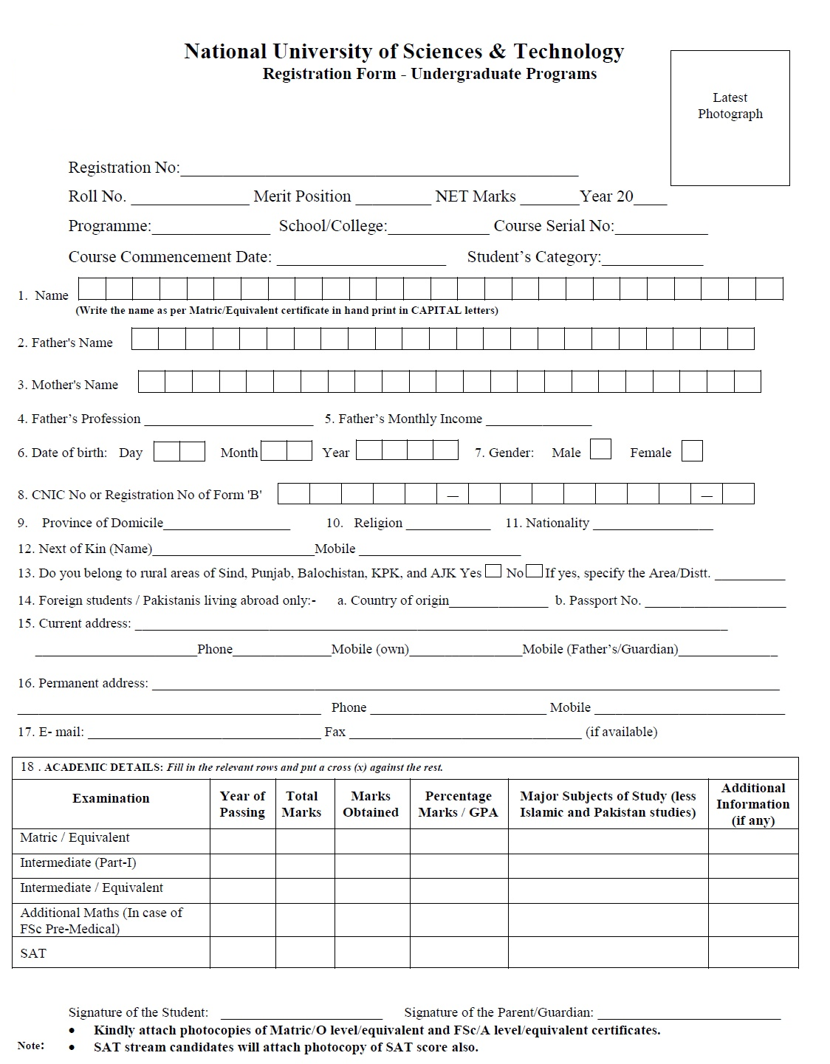
Annex-G

Annex-H

NUST INSTITUTE OF CIVIL ENGINEERING (NICE)
SCHOOL OF CIVIL & ENVIRONMENTAL ENGINEERING (SCEE)
NATIONAL UNIVERSITY OF SCIENCE & TECHNOLOGY (NUST)
H-12 SECTOR, ISLAMABAD

UNDERTAKING

I, ____________________________________ S/O/D/O_______________________________
do hereby solemnly affirm that if I fail to deposit my original documents (SSC/HSSC/O/A Levels) before 30th November 2023, I will not be allowed to sit in 1st Semester examination and my registration will be cancelled.

Dated: _________ 2023 Name:
Address:

I,_________________________________________________________________________
Father/guardian of ___________________________________________________________
do hereby endorse the above undertaking.
Dated:_________ 2023 Name:
Address:

Note:
This undertaking must be provided on a Hundred Rupee Stamp paper duly attested / stamped by OATH COMMISSIONER.

