NUST INSTITUTE OF CIVIL ENGINEERING (NICE)
Annex A
SCHOOL OF CIVIL & ENVIRONMENTAL ENGINEERING (SCEE)
NATIONAL UNIVERSITY OF SCIENCE & TECHNOLOGY (NUST)
H-12 SECTOR, ISLAMABAD

Orientation Programme of BE (CivilEngg) UG CE-2021 (Fall Semester)

(Summary)

Date | Events | Time (Hours) | Venue
Monday  8th Nov 2021  Day-1 | Reception at School and Registration | 0900 to 1050 hrs | SCEE (NICE) Building
 | Address by Principal SCEE | 1100 hrs | SCEE Seminar Hall
 | Qalam Orientation by Lecturer  Ms Qurrat-ul-ain Babar | 1115 to 1130 hrs | SCEE Seminar Hall
 | Tea Break | 1130 to 1200 hrs | Corridor
 | IESE & IGIS Alumni Talks  (Departure by NUST Transport will be provided) | 1200 to 1300 hrs | Respective Institute’s  Locations
 | NICE Alumni Talks | 1200 to 1300 hrs | SCEE Seminar Hall
 | Lunch / Prayers break & Departure to Convocation Ground | 1300-1400 hrs | Open
 | Gathering Freshmen for Batch Photo | 1415- 1515 hrs | Convocation Ground
 | Batch Photo | 1530-1730 hrs | Convocation Ground
 | Address to Parents by Pro Rector (A) | 1430-1500 hrs | Jinnah Auditorium
 | Briefing & Q/A session with Parents &  Tea (it will be a parallel event with Batch Photo) | 1500-1700 hrs | Jinnah Auditorium /  DD SA will act as MoC
Tuesday  9th Nov 2021  Day-2 | Registration /  Documents Collection | 0930-1300 | PG Wing Room # 25,26,27
 | Prayer Break | 1300-1400
 | Ice Breaking Activities /  Life at NUST / Sports | 1400-1700 | NUST Campus
Wednesday  10th Nov 2021  Day-3 | Detailed Programme Attached in Instructions
Thursday
11th Nov 2021
Day-4
Friday
12th Nov 2021
Day-5

NUST INSTITUTE OF CIVIL ENGINEERING (NICE)
SCHOOL OF CIVIL & ENVIRONMENTAL ENGINEERING (SCEE)
NATIONAL UNIVERSITY OF SCIENCE & TECHNOLOGY (NUST)
H-12 SECTOR, ISLAMABAD
Annex-C

UNDERTAKING

I, ____________________________________ S/O/D/O_______________________________
do hereby solemnly affirm that I shall not indulge in any political or sectarian activity during the
course of my studies in BE (Civil Engineering) Session: 2021 - 2025 at NICE-SCEE, Islamabad

Dated: _________ 2021 Name:
Address:

I,_________________________________________________________________________
Father/guardian of ___________________________________________________________
do hereby endorse the above undertaking.
Dated:_________ 2021 Name:
Address:

Note:
This undertaking must be provided on a Fifty Rupee Stamp paper duly attested / stamped by OATH COMMISSIONER.

Annex-D

NUST INSTITUTE OF CIVIL ENGINEERING (NICE)
SCHOOL OF CIVIL & ENVIRONMENTAL ENGINEERING (SCEE)
NATIONAL UNIVERSITY OF SCIENCE & TECHNOLOGY (NUST)
H-12 SECTOR, ISLAMABAD

PARTICULAR OF WARDS OF DEFENCE SERVICE PERSONALS

Name of Student:
Program:
Father’s / Mother’s Name:
(Who is serving or retired from Army/Navy/Air force)
Service No:
Rank:
Arm / Svc / Department:
Last Appointment Before Retiring:
Alive / Deceased:
Photocopies of discharge certificate / pension book in case of retired personnels may also be attached.

Signature of the Parent Signature of the student
Date: Date:

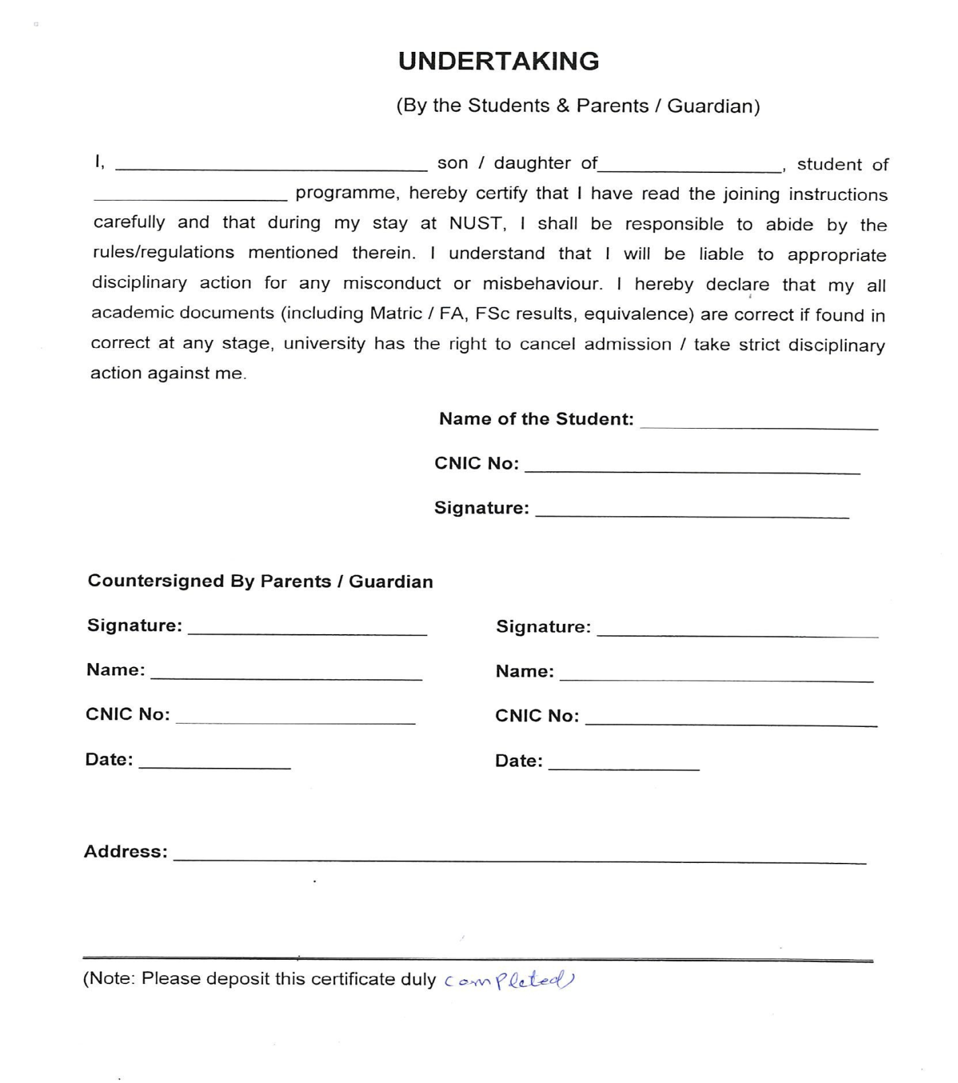
Annex-E

Medical Fitness Certificate
Annex-F

(Photograph)
Roll No/Registration No: -----------------------------------------------
Name: -----------------------------------------------
Father’s Name: -----------------------------------------------
Gender: -----------------------------------------------
Age: -----------------------------------------------
- Weight: ---------------------------------- (kg) Height -------------------- (cm) BP ------------------------
- Lungs: ------------------------------------------------------------ Blood Gp. --------------
- Heart: ------------------------------------------------------------
- Vision: Left Eye ----------------- Right Eye ---------------- Details of Glasses (if worn): ----------------
- Hearing: ---------------------------------------------------------
- Any Impediment in Speech: --------------------------------------------------------------------------------------
- Any Disability: --------------------------------------------------------------------------------------------------------
- Any Neurological / Psychiatric disease, (if yes, please give details). ------------------------------------
- Suffering from Hepatitis B / Hepatitis C / HIV (AIDS) -------------------------------------------------------
- Any significant Disease Diagnosed in the past: --------------------------------------------------------------
- Vaccinated (Yes/No/Partially). -----------------------------------------------------------------------------------
- Taking any medicine on regular basis (if yes, please give details). --------------------------------------
- Allergies if any: -------------------------------------------------------------------------------------------------------
- Any Communicable / Contagious Disease: -------------------------------------------------------------------
- Mark of Identification: --------------------------------------
I certify that I have examined Mr / Ms ----------------------------------------------------------------Son / Daughter of ------------------------------------------------------ who is an applicant for admission to Undergraduate/ Postgraduate Program at NUST and could not notice that he / she has any physical or mental disease and is FIT for undertaking studies.
Signature of Doctor with legible seal | Signature of Candidate (In presence of Doctor)
PM & DC No:
Dated: | Dated:
Note for Candidate: Please present your medical fitness certificate at the concerned NUST College/School at the time of joining.
MEDICAL STANDARDS FOR ADMISSION
Study at NUST demands good physique and stamina. An applicant must have sound health so as to bear the strain of the course.
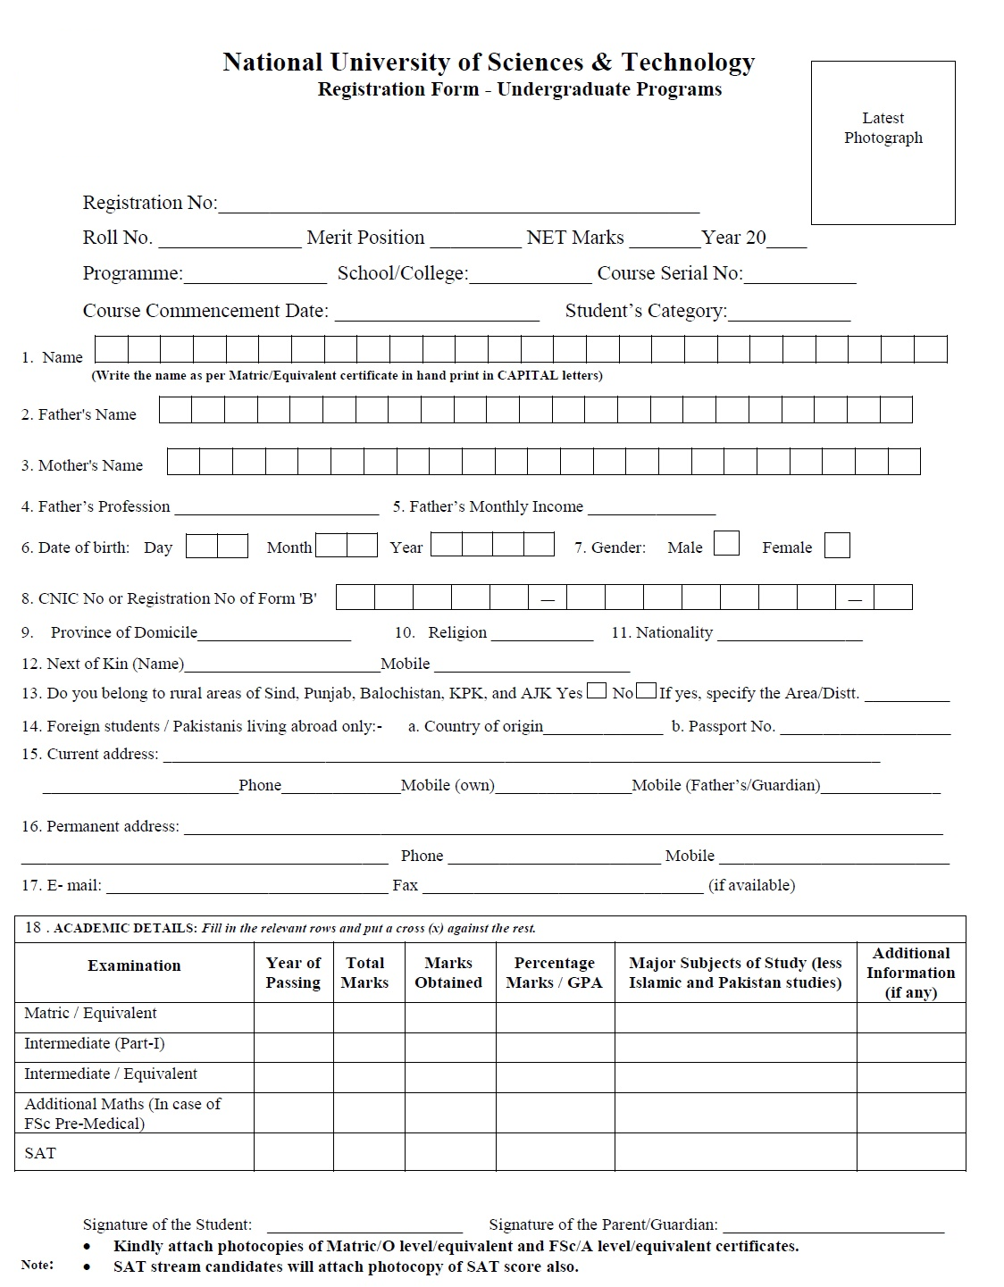
Annex-G

